UNIT-III

LOCUS DIAGRAMS & RESONANCE
    - A series RLC circuit has R=10Ω, L=0.5H and C=40μF. The applied voltage is 100V. Find (a) Resonant frequency & Quality factor of a coil (b) Bandwidth (c) Upper and lower
Half power frequencies (d) Current at resonance & current at half power points (e) Voltage across inductance & voltage across capacitance at resonance.

    - (a) In a parallel resonance circuit (Tank circuit) R=2Ω, L=1mH and C=10μF, Find the Resonant frequency, Dynamic impedance and Bandwidth.
(b) Obtain the expression for resonant frequency for parallel RL-RC circuit.

    - Obtain the expression for resonant frequency for parallel R-L-C circuit.

    - Obtain the expression for resonant frequency, bandwidth and Q-factor for Series R-L-C circuit.

    - Two coils one of R₁=0.51Ω, L₁=32mH and other coil of R₂=1.3Ω, L₂=15mH are in series and are connected in series with a capacitor of C₁=25μF, C₂=62μF and a resistor of R₃=0.24Ω. Determine (a) Resonant frequency (b) Quality factor of the circuit (c) Bandwidth (d) Power dissipated in the circuit at resonance frequency if the supply is 230V AC Supply.
    - Write the comparison between series resonance and parallel resonance?
    - Draw the Locus diagram of a Series RL Circuit?
    - Draw the Locus diagram of a Series RC Circuit?
    - Derive the expression for resonant frequency of a Tank Circuit?
    - In a parallel Resonant circuit shown in figure. (1), find the Resonant frequency, Dynamic Impedance, Bandwidth, Q-factor and Current at resonance?
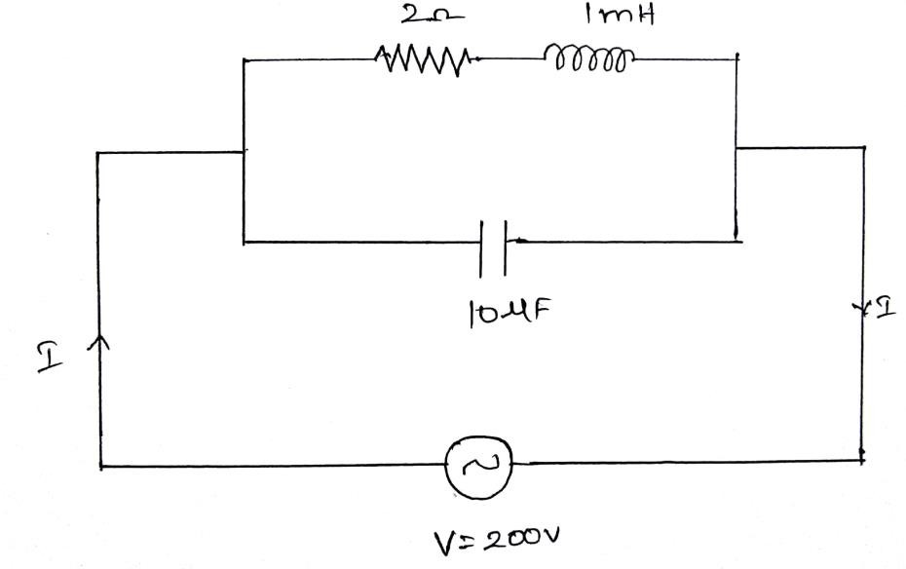
Fig.(1)

    - A series RLC circuit consists of a 50Ω. Resistance, 0.2 H inductance and 10F capacitor with an applied voltage of 20 V. determine the resonant frequency. Find the Q factor of the circuit. Compute the lower and upper frequency limits and also find the bandwidth of the circuit.
    - For the circuit shown in figure 1, determine the value of capacitive reactance and impedance at resonance.
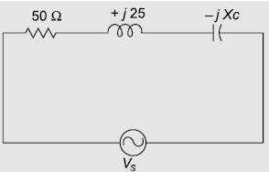
Figure1

13.a) Explain about Parallel resonance with phasor diagrams.
b) Find the value of „L‟ at which the circuit resonates at a frequency of 1000 rad/sec in the circuit shown in figure.
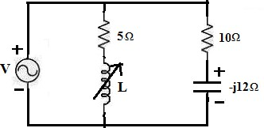

14.a) Derive the expression of resonant Frequency of the following circuit. ]
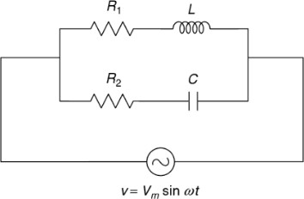
  - Find the value of C in the circuit shown to get resonance.

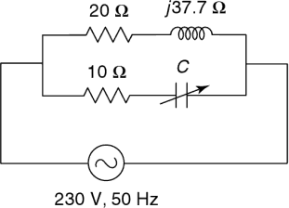
15. Define (a) Resonant frequency (b) Bandwidth (c) Quality factor

